In Spring, the framework takes responsibility for creating and managing the lifecycle of objects. We can eliminate the need for extensive XML or manual Java-based configurations by simply marking a class with the @Component annotation to define it as a bean.
Typically, when an ApplicationContext is initialized, it looks for explicit configuration instructions. However, when using @Component, the context needs a way to discover these annotated classes. To bridge this gap, we use the @ComponentScan("base_package_path") annotation in our configuration file. This tells Spring exactly where to look to find and instantiate our beans automatically.
Key Technical Clarifications:
To make your explanation even more accurate, here are a few nuanced points to keep in mind:
The "No Configuration" Myth: While @Component reduces manual work, you still technically need at least one configuration point (like a class annotated with @Configuration) to host the @ComponentScan.
Config File:
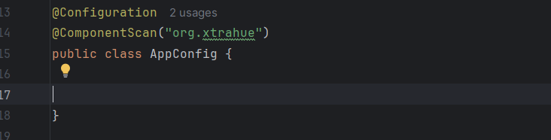
However, this approach will lead to an error if a class has a dependency that Spring cannot resolve automatically. For instance, if the Alien class depends on the Computer interface, Spring needs to know how to link them. To resolve this, we use the @Autowired annotation above the Computer dependency declaration in the Alien class. This instructs Spring’s IoC container to find a matching bean and inject it automatically. Or, we can use the @Autowired annotation above the setter of Computer.
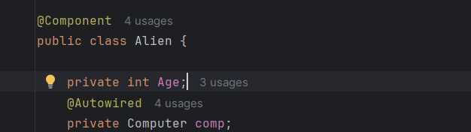

If multiple beans of the same type exist in the context, Spring will encounter a 'NoUniqueBeanDefinitionException' and fail to start. For example, if both Laptop and Desktop implement the Computer interface, Spring won't know which one to inject into the Alien class.
To resolve this conflict, we have two primary options:
- @Qualifier: Use @Qualifier("laptop") alongside @Autowired to specify the exact bean name you want to inject. By default, bean names follow the camelCase convention (the class name starting with a lowercase letter).
- @Primary: Mark one of the implementation classes (e.g., Laptop) with the @Primary annotation. This tells Spring to treat that specific bean as the default choice whenever multiple candidates are available."

Value Annotation: To inject default value-
